/*
Name: Shubham Sarang
Roll no: 1345
Unit 5: Linked list
Program: Singly Linked List
*/

#include<iostream>
#include<conio.h>
using namespace std;

//Node template
class Node
{
public:
int data;
Node *next;
};

//List tempate
class SList
{
Node *head;

public:
SList()
{
head=NULL;
}
void Insert(int x);
void Display();
void Length();
void Search(int x);
void Remove(int x);
};
// Functions
void SList :: Insert(int x)
{
//create node t
Node *t= new Node();
t->data=x;
t->next = NULL;

//first node in the list
if(head == NULL)
{
head = t;
return;
}

//traverse till last node
Node *tmp = head;

while(tmp->next != NULL)
{
tmp= tmp->next;
}
//attach t to the last node tmp
tmp->next = t;
}
void SList :: Display()
{
Node *tmp = head;
while(tmp!=NULL)
{
cout<<tmp->data<<"->";
tmp = tmp->next;
}
cout<<"End of list";
}

void SList :: Length()
{
Node *tmp = head;
int count=0;
while(tmp!=NULL)
{
count++;
tmp = tmp->next;
}
cout<<"Number of elements in list is "<<count;
}

void SList :: Search(int x)
{
Node *tmp=head;
int flag=0;

while(tmp!=NULL)
{
if(tmp->data==x)
{
flag=1;
break;
}
tmp=tmp->next;
}

if(flag==1)
{
cout<<"Element "<<x<<" found";
}
else
{
cout<<"Element "<<x<<" not found";
}
}

void SList :: Remove(int x)
{
//Step 1:List in empty return control
if(head==NULL)
{
cout<<"LIST IS EMPTY";
return;
}
//Step 2: Search element
Node *tmp = head;
Node *prev = NULL;
int flag = 0;

while(tmp!=NULL)
{
if(tmp->data == x)
{
flag = 1;
break;
}
prev = tmp;
tmp = tmp->next;
}

//step 3: unsuccessfull search return control
if(flag==0)
{
cout<<"Element "<<x<<" not found ";
return;
}

//Step 4: Successful search, a single node deletion
if(tmp == head && tmp->next == NULL)
{
head = NULL;
}
else if(tmp==head) //step 4 b: head node deletion
{
head = tmp->next;
}
else if(tmp->next == NULL) //step4 c: tail node deletion
{
prev->next = NULL;
}
else //Step 4 d: any node in the middle
{
prev->next = tmp->next;
}
//Step 5: delete the node containing x
delete tmp;
cout<<"Element deleted ";
}
//Menu

int main()
{
int ch, num, y;
SList s;
while(1)
{
system("cls");
cout<<"**Singly linked list**"<<endl;
cout<<"1. Insert in SLL\n";
cout<<"2. Display List\n";
cout<<"3. Length of SLL\n";
cout<<"4. Search for the node in SLL\n";
cout<<"5. Remove a node\n";
cout<<"6. Exit\n\n";

cout<<"Enter your choice: ";
cin>>ch;

switch(ch)
{
case 1:
cout<<"Enter the data: ";
cin>>num;
s.Insert(num);
getch();
break;
case 2:
s.Display();
getch();
break;
case 3:
s.Length();
getch();
break;
case 4:
cout<<"Enter the element to be searched: ";
cin>>y;
s.Search(y);
getch();
break;
case 5:
cout<<"Enter the element to be removed: ";
cin>>y;
s.Remove(y);
s.Display();
getch();
break;
case 6:
exit(1);
default:
cout<<"Incorrect option";
getch();
}//end of switch

}//end while

}//end main

output:
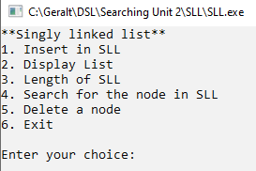
Enter Elements:

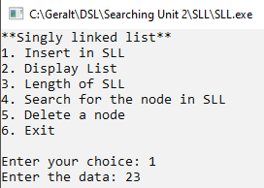
Display elements:
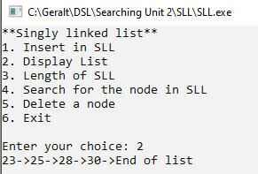
Length of list:
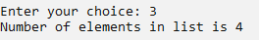
Search element:
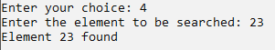
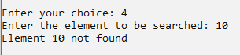

Head Node Deletion:
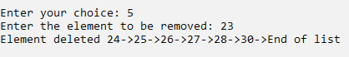
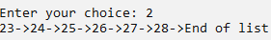
Tail Node Deletion:
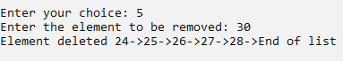
Any Node Deletion:
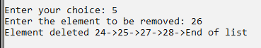

Program:
/*
Name: Shubham Sarang
Roll no: 1345
Unit 5: Linked list
Program: Circular Linked List
*/

#include<iostream>
#include<conio.h>
using namespace std;

//Node template
class CNode
{
public:
int data;
CNode *next; //declare data to store value and create node

};

//list template
class CList
{
CNode *first; //first node
CNode *last; //last node

public:
CList()
{
first = NULL;
last = NULL;
}
void Insert(int x); //Methods
void Display();
void Length();
void Search(int x);
void Remove(int x);
};

//functions

void CList :: Insert(int x)
{
CNode *t = new CNode(); //temporary node to store value
t->data = x;
t->next = NULL;

if(first == NULL && last == NULL) //head node
{
first = t;
last = t;
last->next = first;
}
else
{
last->next = t; //for next nodes
last = t;
last->next = first;
}

}

void CList :: Display()
{
CNode *tmp = first;
if(first == NULL)
{
cout<<"List is empty";
return;
}
do
{
cout<<tmp->data<<" -> ";
tmp = tmp->next;
}
while(tmp != first);
cout<<" Back to first ";
}

void CList :: Length()
{
int cnt=0;
CNode *tmp = first;
if(first == NULL)
{
cout<<"List is empty";
return;
}
do
{
cnt++;
tmp = tmp->next;
}
while(tmp != first);
cout<<cnt;
}

void CList :: Search(int x)
{
CNode *tmp = first;
int flag = 0;
if(first == NULL)
{
cout<<"List is empty";
return;
}
do
{
if(tmp->data == x)
{
flag = 1;
break;
}
tmp = tmp->next;
}
while(tmp != first);
if(flag == 0)
{
cout<<x<<" not found ";
}
else
{
cout<<x<<" found ";
}
}

void CList :: Remove(int x)
{
CNode *tmp = first;
CNode *prev = NULL;
int flag = 0;
if(first == NULL) //empty list and return control
{
cout<<"List is empty";
return;
}

do
{
if(tmp->data == x)
{
flag = 1;
break;
}
prev = tmp;
tmp = tmp->next;

}while(tmp != first);

if(flag == 0) //unsuccessful deletion
{
cout<<x<<" not found";
return;
}

if(first == last) //single node deletion
{
first == NULL;
last == NULL;
}
else if(tmp == first) //first node deletion
{
first = tmp->next;
last->next = first;
}
else if(tmp == last) //last node deletion
{
last = prev;
last->next = first;
}
else
{
prev->next = tmp->next;
}
delete tmp;
}

//Menu
int main()
{
int ch;
int num, y, z;
CList c;
while(1)
{
system("cls");

cout<<"**Circular linked list**"<<endl;
cout<<"1. Insert in CLL\n";
cout<<"2. Display List\n";
cout<<"3. Length of CLL\n";
cout<<"4. Search for the node in CLL\n";
cout<<"5. Remove a node\n";
cout<<"6. Exit\n\n";

cout<<"Enter your choice: ";
cin>>ch;

switch(ch)
{
case 1:
cout<<"Insert value: ";
cin>>num;
c.Insert(num); //calling function
getch();
break;

case 2:
cout<<"Display CLL: ";
c.Display();
getch();
break;

case 3:
cout<<"Length of the list is: ";
c.Length();
getch();
break;

case 4:
cout<<"Search the element: ";
cin>>y;
c.Search(y);
getch();
break;

case 5:
cout<<"Enter element to be removed: ";
cin>>z;
c.Remove(z);
c.Display();
getch();
break;

case 6:
cout<<"opt 6";
exit(1);
default:
cout<<"Incorrect option bruv";
getch();
}//end of switch
}//end of while
}//end main

Output:
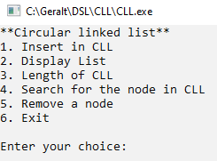
Enter elements:
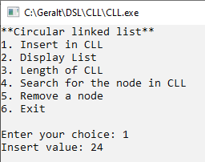
Display List:
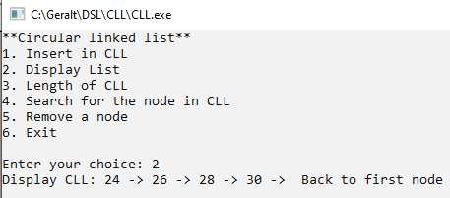
Display length:
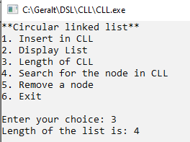

Search element:
Element found:
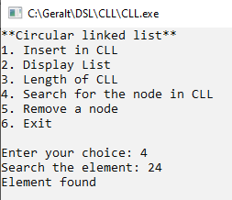
Element not found:
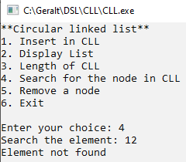
Remove a node:

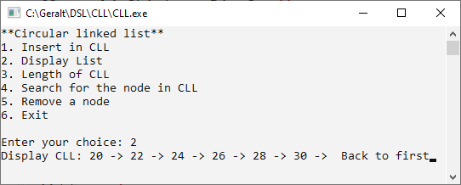

Head node deletion:

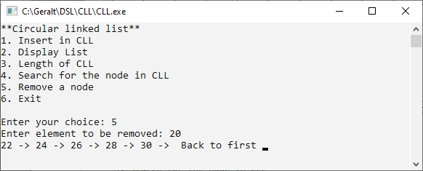
Tail node deletion:

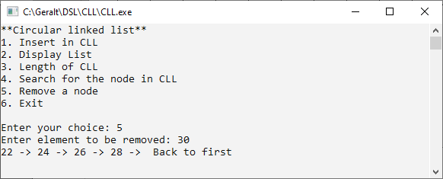
Mid node deletion:

